Iteration 1: Progress Report

Group 1: Cullen Martin, Elton Sinclair, Jayden Pearce

Cullen’s Contributions:

* Hosting the group’s Google Drive for storing completed work

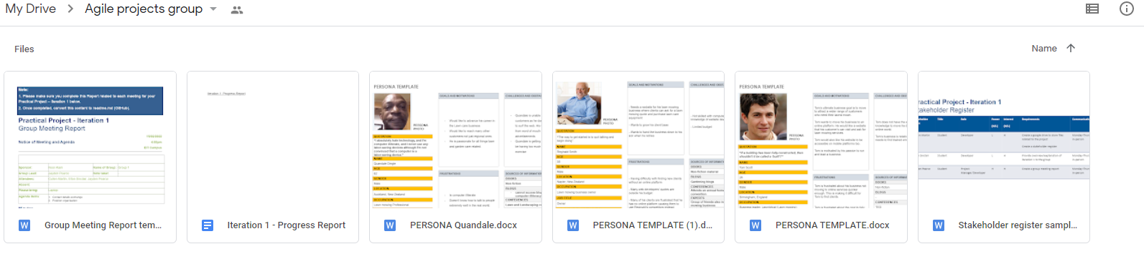

* Creating the stakeholder register for iteration 1

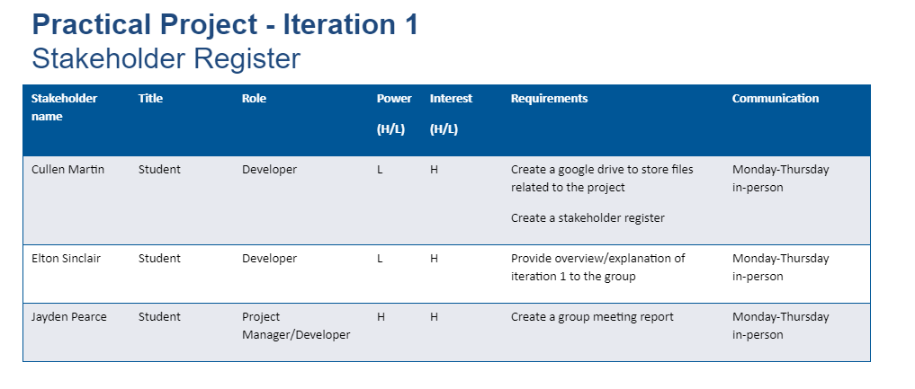

* Creating one of three personas (see next page)

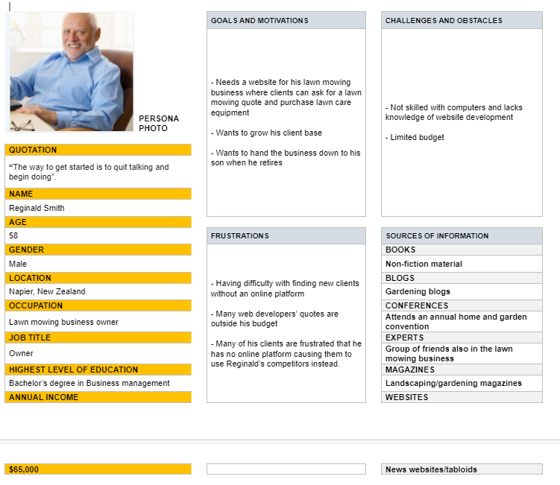

* Writing the progress report for iteration 1

Elton’s contributions:

* Creating one of three personas (see next page)

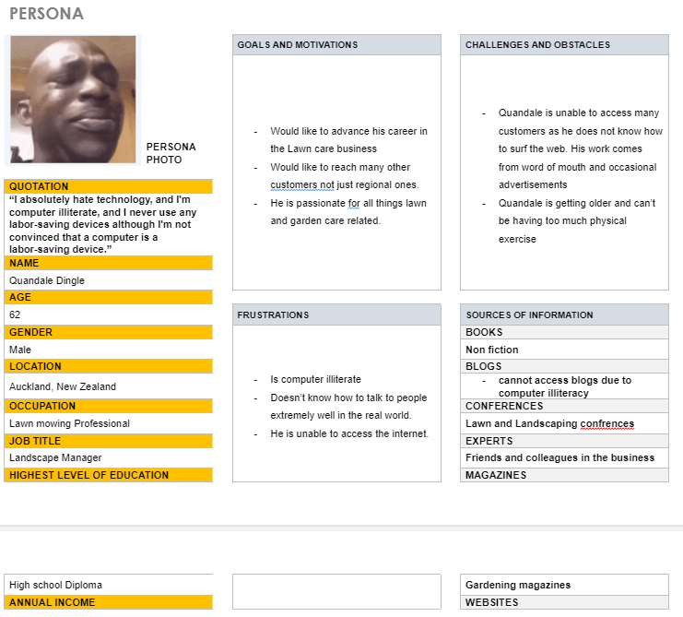

Jayden’s contributions:

* Creating the group meeting report for iteration 1 (see next page)

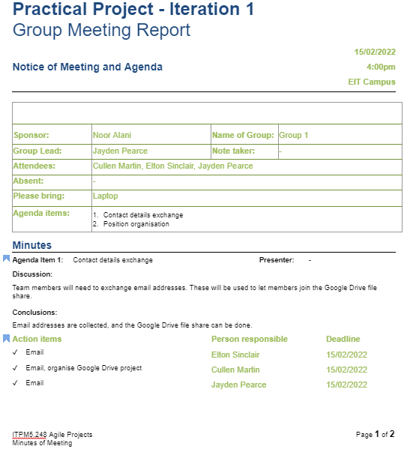

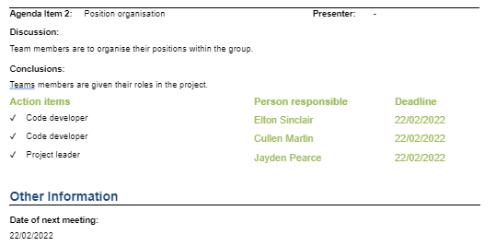

* Creating one of three personas

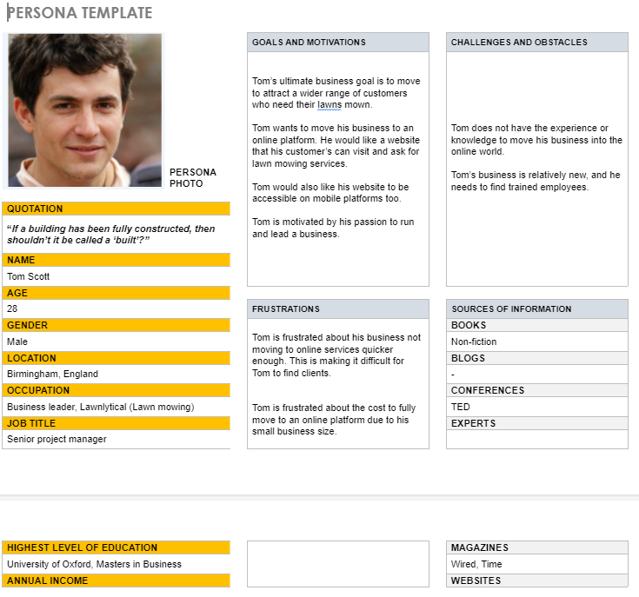

What's working:

As a group we get along quite well and there have been no conflicts with how to complete our tasks for this assignment. Everybody in our group is also capable of working on their contributions independently when necessary. This has been beneficial over the past two weeks where some members have been isolating due to Covid-19. Every member of our group also has a solid grasp of computer literacy and we have had no issues with Google Drive access and other computer-related tasks for this iteration.

What's not working:

Our lack of agreed-upon deadlines for iteration 1 has occasionally led to work being submitted later than what would be comfortable for the group.

What needs improving:

Communication within the group over iteration 1 has been lacking in some areas. Outside of in-person meetings there is almost no dialogue and this needs to improve in case these meetings are no longer feasible during iteration 2.